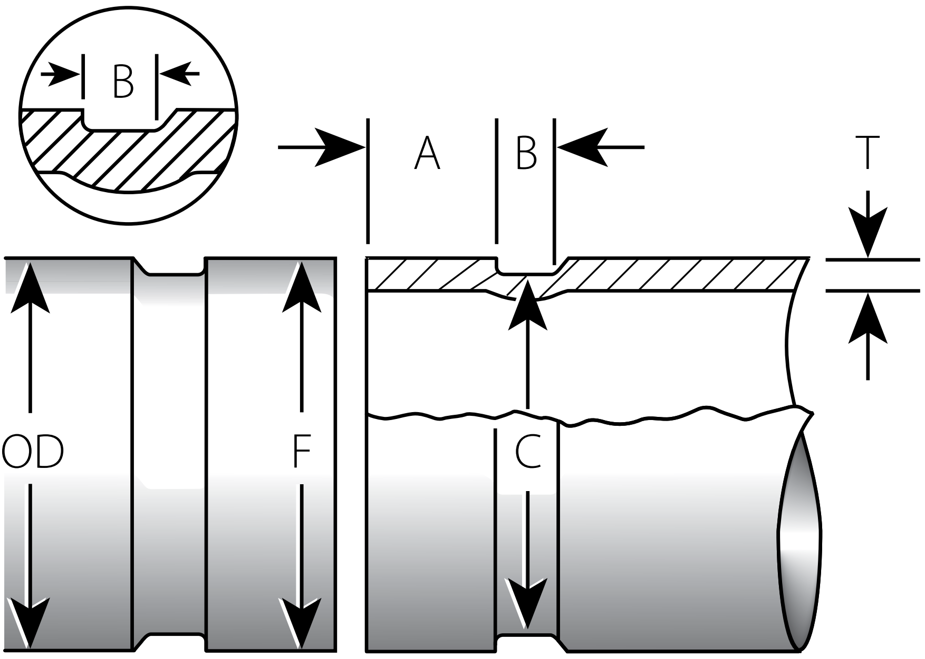
AGS ROLL GROOVE SPECIFICATIONS
For Carbon Steel Pipe And S.S Pipe
--Organized By WELPING & GruvMaster

Actual Pipe Outside Diameter mm | Dimensions - millimeters (mm)
Actual Pipe Outside Diameter mm | Pipe Outside Diameter |  | Gasket Seat “A” |  |  | Groove  Width  "B" | Groove Diameter “C” |  | Norminal Wall Thickness for Grooving "T" |  | Max. Allow. Flare Dia. “F”
Actual Pipe Outside Diameter mm | Max. | Min. | Basic | Max. | Min. | Groove  Width  "B" | Max. | Min. | Carbon Steel | S.S Steel Sch.10S | Max. Allow. Flare Dia. “F”
355.6mm | 358.0 | 354.8 | 38.1 | 38.89 | 36.5 | 11.6 | 342.9 | 341.8 | 5.6–19.1 | 4.8 | 361.4
377.0mm | 379.4 | 376.2 | 38.1 | 38.89 | 36.5 | 11.6 | 364.3 | 363.2 | 5.5–19.1 | – | 382.8
406.4mm | 408.8 | 405.6 | 38.1 | 38.89 | 36.5 | 11.6 | 393.7 | 392.6 | 6.4–19.1 | 4.8 | 412.2
426.0mm | 428.4 | 425.2 | 38.1 | 38.89 | 36.5 | 11.6 | 413.3 | 412.2 | 6.5–19.1 | – | 431.8
457.2mm | 459.6 | 456.4 | 38.1 | 38.89 | 36.5 | 11.6 | 444.5 | 443.4 | 6.4–19.1 | 4.8 | 463.0
480.0mm | 482.4 | 479.2 | 38.1 | 38.89 | 36.5 | 11.6 | 467.3 | 466.2 | 6.5–19.1 | – | 485.9
508.0mm | 510.4 | 507.2 | 38.1 | 38.89 | 36.5 | 11.6 | 495.3 | 494.2 | 6.4–19.1 | 5.5 | 513.8
530.0mm | 532.4 | 529.2 | 38.1 | 38.89 | 36.5 | 11.6 | 517.3 | 516.2 | 6.5–19.1 | – | 535.7
558.8mm | 561.2 | 558.0 | 38.1 | 38.89 | 36.5 | 11.6 | 546.1 | 545.0 | 6.4–19.1 | 5.5 | 564.6
609.6mm | 612.0 | 608.8 | 38.1 | 38.89 | 36.5 | 11.6 | 596.9 | 595.8 | 6.4–19.1 | 5.5 | 615.4
630.0mm | 632.4 | 629.2 | 38.1 | 38.89 | 36.5 | 11.6 | 617.3 | 616.2 | 6.5–19.1 | – | 635.8
660.4mm | 662.0 | 658.8 | 44.5 | 45.29 | 42.9 | 13.6 | 645.9 | 644.4 | 8.0–19.1 | – | 668.0
711.2mm | 712.8 | 709.6 | 44.5 | 45.29 | 42.9 | 13.6 | 696.7 | 695.2 | 8.0–19.1 | – | 718.8
720.0mm | 721.6 | 718.4 | 44.5 | 45.29 | 42.9 | 13.6 | 705.5 | 704.0 | 8.0–19.1 | – | 727.6
762.0mm | 763.6 | 760.4 | 44.5 | 45.29 | 42.9 | 13.6 | 747.5 | 746.0 | 8.0–19.1 | – | 769.6
812.8mm | 814.4 | 811.2 | 44.5 | 45.29 | 42.9 | 13.6 | 798.3 | 796.8 | 8.0–19.1 | – | 820.4
820.0mm | 821.6 | 818.4 | 44.5 | 45.29 | 42.9 | 13.6 | 805.5 | 804.0 | 8.0–19.1 | – | 827.6
863.6mm | 865.2 | 862.0 | 44.5 | 45.29 | 42.9 | 13.6 | 849.1 | 847.6 | 8.0–19.1 | – | 871.2
914.4mm | 916.0 | 912.8 | 44.5 | 45.29 | 42.9 | 13.6 | 899.9 | 898.4 | 8.0–19.1 | – | 922.0
920.0mm | 921.6 | 918.4 | 44.5 | 45.29 | 42.9 | 13.6 | 905.5 | 904.0 | 8.0–19.1 | – | 927.6
965.0mm | 966.6 | 963.4 | 44.5 | 45.29 | 42.9 | 13.6 | 950.7 | 949.2 | 8.0–19.1 | – | 972.8
1016.0mm | 1017.6 | 1014.4 | 50.8 | 51.59 | 49.2 | 14.3 | 1000.1 | 998.6 | 8.0–19.1 | – | 1023.6
1066.8mm | 1068.4 | 1065.2 | 50.8 | 51.59 | 49.2 | 14.3 | 1050.9 | 1049.4 | 8.0–19.1 | – | 1074.4
1117.6mm | 1119.2 | 1116.0 | 50.8 | 51.59 | 49.2 | 14.3 | 1101.7 | 1100.2 | 8.0–19.1 | – | 1125.2
1168.4mm | 1170.0 | 1166.8 | 50.8 | 51.59 | 49.2 | 14.3 | 1152.5 | 1151.0 | 8.0–19.1 | – | 1176.0
1219.2mm | 1220.8 | 1217.6 | 50.8 | 51.59 | 49.2 | 14.3 | 1203.3 | 1201.8 | 8.0–19.1 | – | 1226.8
1270.0mm | 1271.6 | 1268.4 | 50.8 | 51.59 | 49.2 | 14.3 | 1254.1 | 1252.6 | 8.0–19.1 | – | 1277.6
1371.6mm | 1373.2 | 1370.0 | 63.5 | 64.29 | 61.9 | 14.3 | 1357.1 | 1355.6 | 9.5–19.1 | – | 1379.2
1422.4mm | 1424.0 | 1420.8 | 63.5 | 64.29 | 61.9 | 14.3 | 1407.9 | 1406.4 | 9.5–19.1 | – | 1430.0
1473.2mm | 1474.8 | 1471.6 | 63.5 | 64.29 | 61.9 | 14.3 | 1458.7 | 1457.2 | 9.5–19.1 | – | 1480.8

AGS ROLL GROOVE SPECIFICATIONS
For Carbon Steel Pipe And S.S Pipe
--Organized By WELPING & GruvMaster

Actual Pipe Outside Diameter mm | Dimensions - millimeters (mm)
Actual Pipe Outside Diameter mm | Pipe Outside Diameter |  | Gasket Seat “A” |  |  | Groove Width “B” | Groove Diameter “C” |  | Norminal Wall Thickness for Grooving "T" |  | Max. Allow. Flare Dia. “F”
Actual Pipe Outside Diameter mm | Max. | Min. | Basic | Max. | Min. | Groove Width “B” | Max. | Min. | Carbon Steel | S.S Steel Sch.10S | Max. Allow. Flare Dia. “F”
1524.0mm | 1525.6 | 1522.4 | 63.5 | 64.29 | 61.9 | 14.3 | 1509.5 | 1508.0 | 9.5–19.1 | – | 1531.6
1574.8mm | 1576.4 | 1573.2 | 63.5 | 64.29 | 61.9 | 14.3 | 1560.3 | 1558.8 | 9.5–19.1 | – | 1582.4
1625.6mm | 1627.2 | 1624.0 | 63.5 | 64.29 | 61.9 | 14.3 | 1611.1 | 1609.6 | 12.7–19.1 | – | 1633.2
1676.4mm | 1678.0 | 1674.8 | 63.5 | 64.29 | 61.9 | 14.3 | 1661.9 | 1660.4 | 12.7–19.1 | – | 1684.0
1727.2mm | 1728.8 | 1725.6 | 63.5 | 64.29 | 61.9 | 14.3 | 1712.7 | 1711.2 | 12.7–19.1 | – | 1734.8
1828.8mm | 1830.4 | 1827.2 | 63.5 | 64.29 | 61.9 | 14.3 | 1814.3 | 1812.8 | 12.7–19.1 | – | 1836.4
1981.2mm | 1982.8 | 1979.6 | 63.5 | 64.29 | 61.9 | 14.3 | 1966.7 | 1965.2 | 12.7–19.1 | – | 1990.3

